**Create Database BankData;**

* *Use BankData;*
* *Select * from all_tables;*
* *Show Tables;*
* *Create table BankDetails(Sender_Name varchar(256), Sender_Account_ID varchar(256),Reciever_Name varchar(256), Reciever_Account_ID varchar(256), Transaction_Amount double(10,2));// Creates Table*
* *Select *from BankDetails ;*
* *Insert into BankDetails values('Yash', '1234', 'Yashu' , '4321' , '2000');// Checking if the details are adding or not Line is not required*
* *Delete from BankDetails where Sender_Name = 'AnyName';//For deleting the database element it searches for the sender name written inside the single quote and deletes the row*

**Instruction:** *Open MySQL as* ***UserName- root, password-javaprogramJDBC***

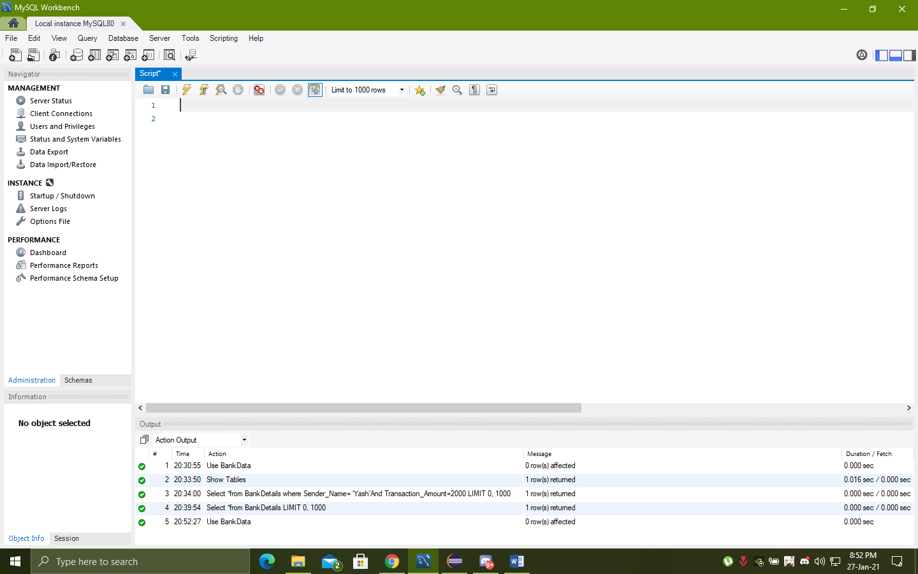

Open the Script file names as script or copy paste above command in workspace

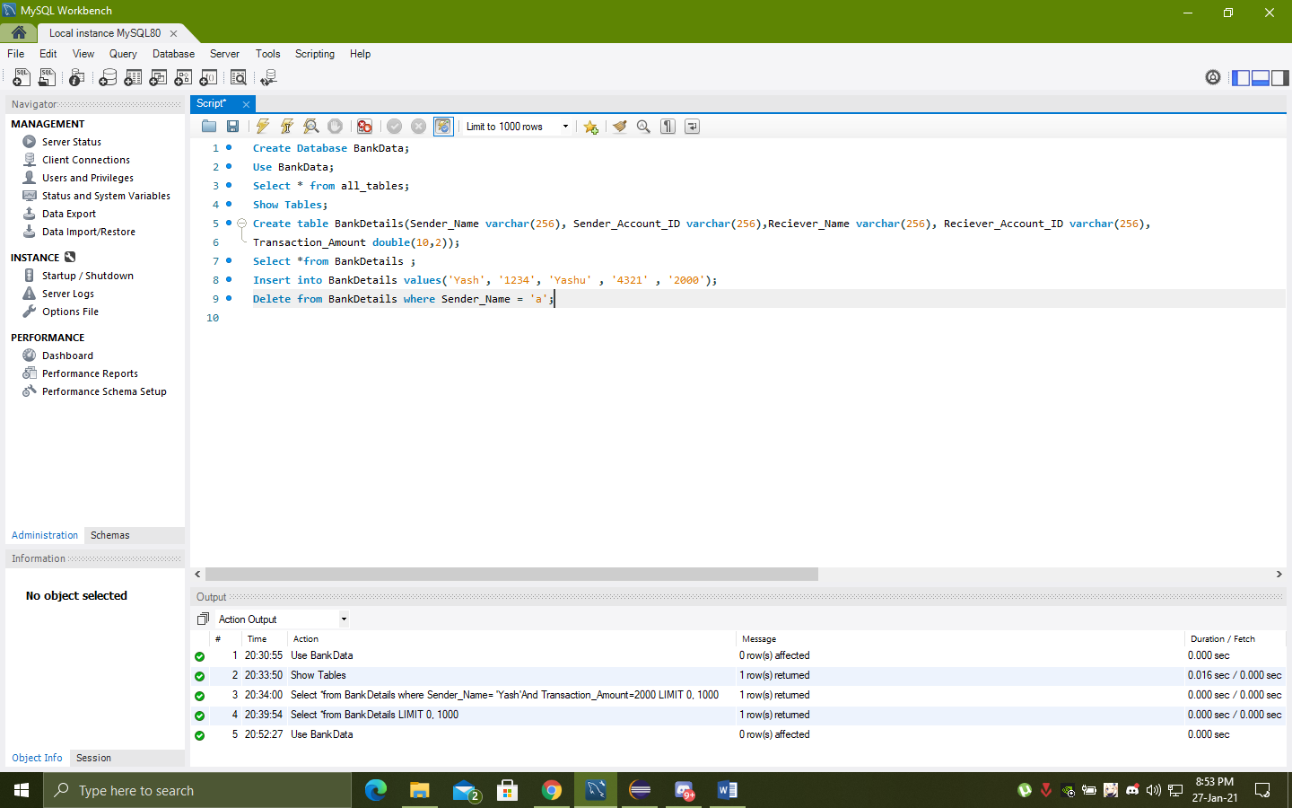

**Execute the 1st Line**

**Goto the 2nd line “Use BankData;” execute the line**

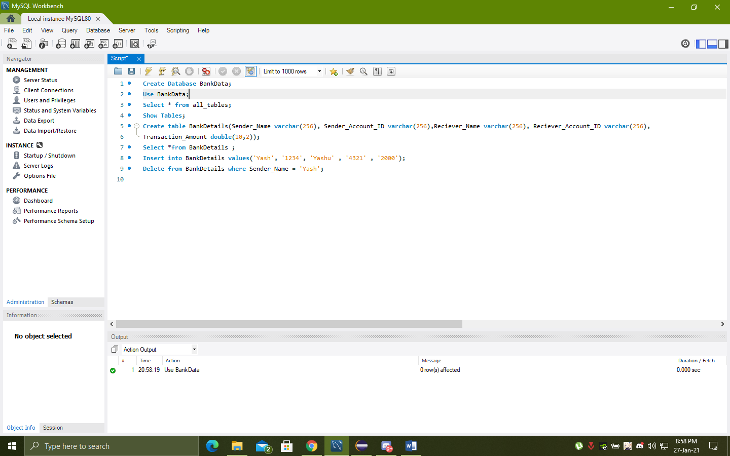

**See output Window**

**Execute 5th and 7th line for creating Table**

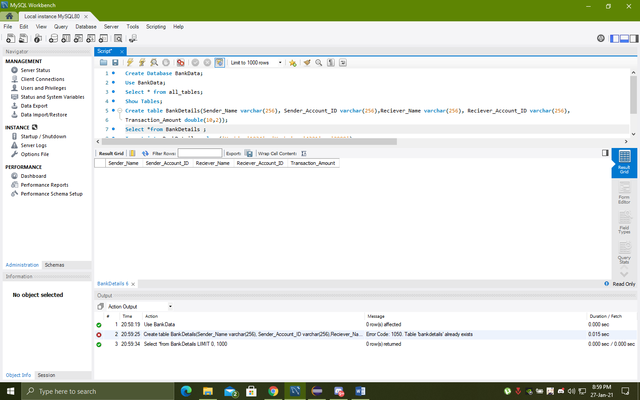

***Table is created***

* **Or run the sript to create database //Optional**
* **Open the program Run it\**

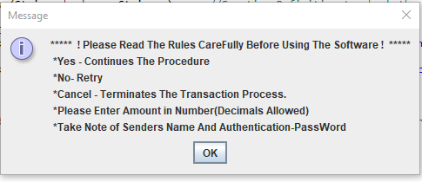

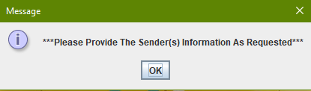

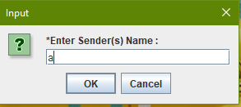

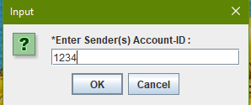

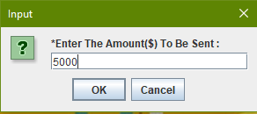

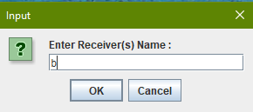

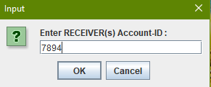

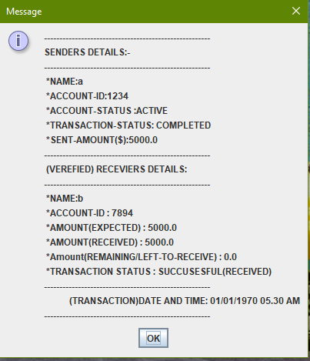

* **All the Transaction Detail Details will be added to the database**
* **After the transaction is done to check the database if details is added goto the workspace in sql and execute the 7 th line “Select *from BankDetails ;” it will show all the details**

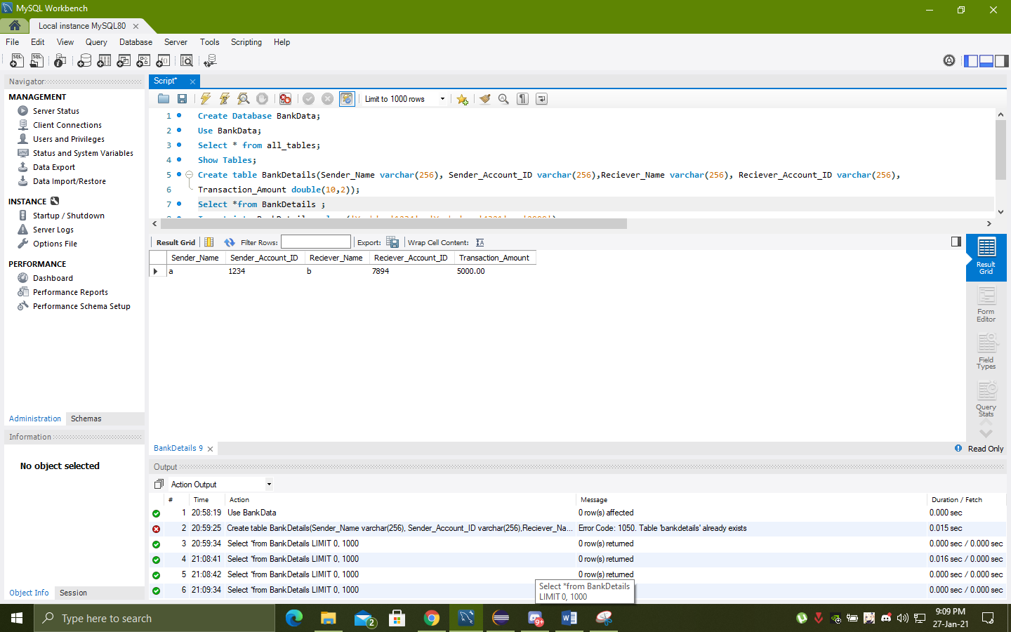  
**Members:**

* **Akshat Sharma 19BCE10147**
* **Ashmita Pal 19BCE10443**
* **Arka Mazumdar 19BCG10020**
* **Arpit Singh 19BCG10069**
* **Yashvardhan Pandey 19BCG10089**